- Create labeled matrices (5×4, 3×3, 2×2) filled by row/column.

Aim:
To create labeled matrices (5×4, 3×3, 2×2) filled by row/column.
Procedure:
Step 1: Open RStudio or R console on your system.
Step 2: Create a matrix by arranging a sequence of numbers into rows and columns. Step 3: Display the created matrix to check its elements and layout.
Step 4: Create another matrix with a different size (for example, 3×3) to understand matrix creation with various dimensions.
Step 5: Display the second matrix to verify its arrangement.
Step 6: Create a smaller matrix (for example, 2×2) to observe how matrix size can vary. Step 7: Display the third matrix to view its content.
Step 8: Observe that each matrix organizes elements in a rectangular form with equal- length rows and columns.
Program:
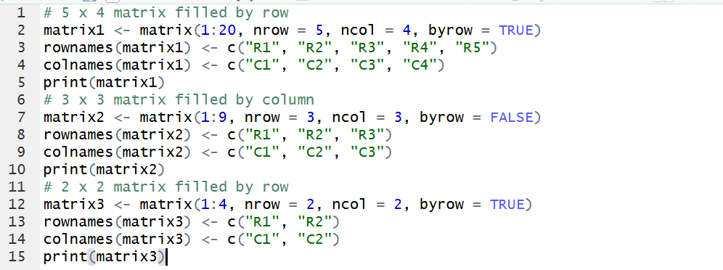
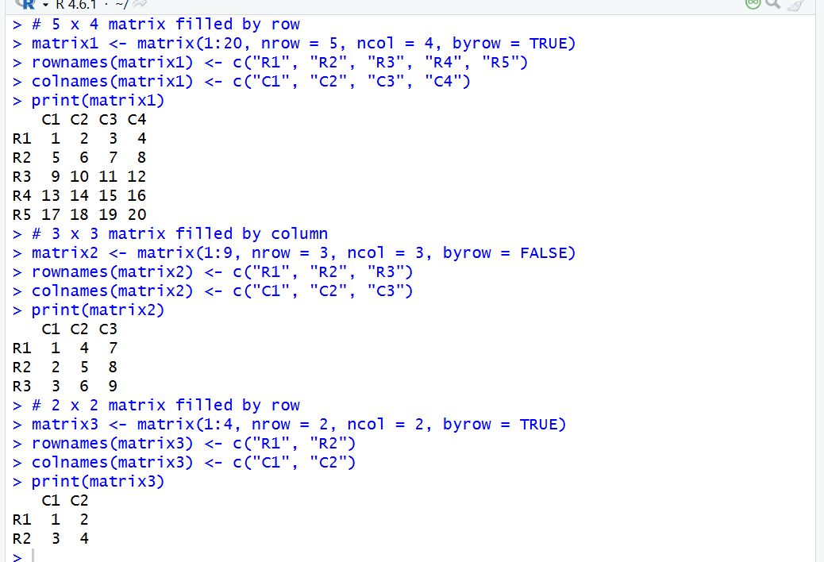
Result: Hence the output is verified Succeessfully.

